LensLog
A Photo Portfolio System

Done by: Faheem Mohammed Shabeer
Class: XII A
Admission Number: 10212
Subject: Computer Science
School : Birla Public School
Academic Year: 2026-27

INDEX

1. Acknowledgement 4

2. Project Specifications 5-6

3. Software Specifications 7-8

4. Hardware Requirements 8

5. Python Source Code 9-26

6. mySQL Tables 27

7. Output 27-29

8. Limitations and Scope 30

9. Bibliography 31

ACKNOWLEDGEMENT

I would like to express my sincere gratitude and deep sense of appreciation to my Computer Science teacher, Mrs. Arshi Habiba, for their invaluable guidance, constant encouragement, and continuous support throughout the development of this project, LensLog - Photography Portfolio Management System. Their insightful suggestions and constructive feedback played a pivotal role in the successful completion of this work.
I extend my heartfelt thanks to our respected Principal, Dr. Anand Nair, and the school administration of Birla Public School for providing the necessary infrastructure, well-equipped computer laboratories, and a conducive environment to carry out this project work.
I am also deeply grateful to the Central Board of Secondary Education (CBSE) for incorporating practical project work into the Class XII Computer Science (083) curriculum, which provided me with a platform to gain hands-on experience in integrating Python GUI programming with MySQL relational databases.
Finally, I express my warm appreciation to my parents and classmates for their endless encouragement, moral support, and cooperation during the course of this project.

PROJECT SPECIFICATIONS

The LensLog Photography Portfolio Management System is a dedicated desktop application developed to simplify the digital asset management workflow for photographers. In modern photography, managing extensive collections of image files alongside complex metadata—such as camera body, lens, focal parameters, shooting location, editing status, and ratings—presents a significant organizational challenge.
LensLog solves this problem by providing a centralized database interface where photographers can systematically store, search, modify, and analyze their portfolio without storing bulk image binaries directly inside the database. Instead, it utilizes absolute image path pointers linked directly to the local file system.
2. Objectives of the Project
- Centralized Metadata Management: To create a robust system that records key photographic parameters (ISO, Shutter Speed, Aperture, Lens, Camera Model, Location, Date, Rating, and Editing Status).
- Seamless Database Connectivity: To establish reliable CRUD (Create, Read, Update, Delete) operations between Python and MySQL Server using standard NCERT-compliant database connectors.
- Interactive Desktop GUI: To provide an intuitive, user-friendly graphical user interface using Python's Tkinter library, eliminating the need for complex command-line interaction.
- Integrated Media Viewer: To bridge database records with local file systems, offering real-time thumbnail previews inside the interface and launching full-resolution images natively via the operating system's photo viewer.
- Data Visualization & Analytics: To generate visual statistical reports (bar graphs and pie charts) on photo categories and rating distributions using Matplotlib and Pandas.
3. Scope of the System LensLog is engineered specifically for independent photographers, digital archivists, and photography students. The system ensures high data integrity by keeping metadata structured inside a relational database schema while retaining the original high-resolution image files safely in their local storage directories.

4. System Architecture & Design The architecture of LensLog follows a standard Two-Tier Desktop Architecture, separating the presentation layer (Tkinter GUI) from the data storage layer (MySQL Database).
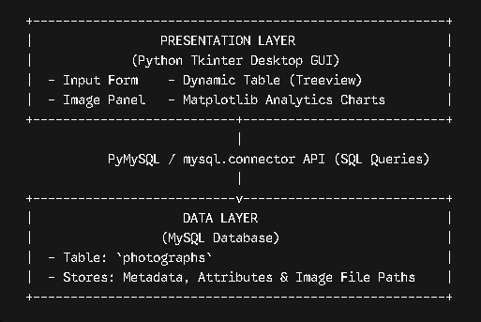

5. Module Descriptions
- Form Entry Module: Captures key photograph details including Title, Category, Location, Date Taken, Camera, Lens, ISO, Shutter Speed, Aperture, Rating, and Editing Status.
- Database Operations Engine (CRUD): Implements parameterized SQL statements to execute SQL INSERT, SELECT, UPDATE, and DELETE queries safely without SQL injection risks.
- Image Handler & Path Resolver: Converts local file paths using standard operating system normalization routines, rendering thumbnail previews via Pillow (PIL) and triggering default system image viewers.
- Data Visualization & Export Module: Uses Pandas dataframes to fetch portfolio snapshots from MySQL and leverage Matplotlib to generate visual charts (Category counts and Rating proportions) alongside CSV exports.

SOFTWARE SPECIFICATIONS

1. Python (Programming Language) Python is a high-level, interpreted, general-purpose programming language known for its clear syntax and strong standard library. In this project, Python acts as the core application engine. It handles business logic, constructs the Graphical User Interface (GUI), manages image processing, and orchestrates database transactions through object-oriented design.
- Tkinter (tkinter): Python's standard built-in GUI toolkit. It provides the framework for windows, input fields, labels, buttons, frames, and the tabular Treeview control used to present database records dynamically.
- mysql-connector-python: An official MySQL driver written in pure Python. It enables NCERT-standard database connectivity, executing parameterized SQL statements (INSERT, UPDATE, DELETE, SELECT) safely over an active connection.
- Pillow (PIL): An advanced image processing library. It loads external image files from disk, resizes high-resolution photographs into thumbnail previews maintaining aspect ratios, and converts them into Tkinter-compatible canvas images.
- Pandas (pandas): A fast and flexible data analysis library. It queries the MySQL database directly into structured DataFrames, facilitating statistical aggregations and single-click exports to CSV format.
- Matplotlib (matplotlib.pyplot): A comprehensive visual plotting library. It takes structured data from Pandas and renders visual graphical analytics—specifically categorical bar charts and rating distribution pie charts—inside interactive figure windows.
2. MySQL Database Management System MySQL is an open-source Relational Database Management System (RDBMS) that uses SQL. It handles all persistent data storage for the system.
- Relational Schema: Stores photographic metadata in a structured format within the photographs table inside the lenslog_db database schema.
- Data Integrity & Data Types: Utilizes optimized SQL column types such as INT AUTO_INCREMENT for primary keys, VARCHAR for text strings, DATE for capture timestamps, and INT for numerical EXIF fields.
- Decoupled Binary Storage: Instead of storing heavy binary BLOB data inside the database (which degrades database performance), MySQL stores clean, indexed file path strings (VARCHAR(255)). This links database rows directly to the local operating system file system.
3. Operating System Interface & Path Resolution Subsystems To ensure stable cross-platform performance and prevent system crashes caused by operating system file paths, the software leverages Python's native system libraries.
- OS Module (os & os.path): Manages file path normalization across the Windows file system. It uses functions like os.path.exists() to verify image file availability before rendering and os.path.normpath() to correct directory backslashes.
- System Process Launcher (os.startfile): Directly interfaces with the Windows Shell to launch images in their native resolution using the operating system's default viewer (e.g., Windows Photos) without consuming extra application memory.

HARDWARE REQUIREMENTS

To run the LensLog Portfolio Management System smoothly alongside the MySQL database server, the development and deployment environment should meet or exceed the following hardware specifications:
1. Minimum Hardware Requirements
- Processor (CPU): Intel Core i3 (2nd Gen) / AMD FX-series or equivalent (1.8 GHz dual-core)
- System Memory (RAM): 4 GB DDR3
- Hard Disk Drive (HDD): 500 MB of available storage for software installations and database storage
- Display Output: 1366 x 768 resolution monitor (16:9 aspect ratio)
- Input Devices: Standard QWERTY Keyboard and Mouse/Trackpad
2. Recommended Hardware Requirements
- Processor (CPU): Intel Core i5 / AMD Ryzen 5 or higher (Quad-core 2.5 GHz+)
- System Memory (RAM): 8 GB DDR4 or higher
- Storage (SSD): Solid State Drive with at least 2 GB available space for quick database read/write speeds and instant image rendering
- Display Output: Full HD (1920 x 1080) resolution display for optimal GUI layout scaling
- Input Devices: Scroll-wheel Mouse for quick Treeview navigation

PYTHON SOURCE CODE

import os
from tkinter import filedialog, messagebox, ttk
import tkinter as tk
import matplotlib.pyplot as plt
import mysql.connector
import pandas as pd
from PIL import Image, ImageTk

def get_connection():
"""Establishes connection to MySQL server using NCERT standard syntax."""
try:
connection = mysql.connector.connect(
host="localhost", user="root", password="Fahe2009", database="lenslog_db"
)
return connection
except mysql.connector.Error as err:
messagebox.showerror("Database Error", f"Failed to connect: {err}")
return None

class LensLogApp:
def __init__(self, root):
self.root = root
self.root.title("LensLog - Photography Portfolio Management System")
self.root.geometry("1100x650")
self.selected_file_path = ""
# Setup GUI Sections
self.create_header()
self.create_form_frame()
self.create_table_frame()
self.create_preview_frame()
# Load Data on Startup
self.fetch_all_records()

def create_header(self):
header = tk.Frame(self.root, bg="#1e293b", height=50)
header.pack(fill="x")
title_label = tk.Label(
header,
text="LENSLOG PORTFOLIO MANAGER",
font=("Arial", 16, "bold"),
fg="white",
bg="#1e293b",
)
title_label.pack(pady=10)
def create_form_frame(self):
form_frame = tk.LabelFrame(
self.root,
text=" Photograph Metadata ",
font=("Arial", 10, "bold"),
padx=10,
pady=10,
)
form_frame.place(x=10, y=60, width=320, height=570)
fields = [
("Title:", "entry_title"),
("Category:", "entry_cat"),
("Location:", "entry_loc"),
("Date (YYYY-MM-DD):", "entry_date"),
("Camera Used:", "entry_cam"),
("Lens Used:", "entry_lens"),
("ISO:", "entry_iso"),
("Shutter Speed:", "entry_shutter"),
("Aperture:", "entry_aperture"),
]
self.inputs = {}
row_idx = 0
for label_text, attr_name in fields:
tk.Label(form_frame, text=label_text, anchor="w").grid(
row=row_idx, column=0, sticky="w", pady=2
)
entry = tk.Entry(form_frame, width=22)
entry.grid(row=row_idx, column=1, pady=2)
self.inputs[attr_name] = entry
row_idx += 1

# Rating Combo
tk.Label(form_frame, text="Rating (1-5):", anchor="w").grid(
row=row_idx, column=0, sticky="w", pady=2
)
self.rating_cb = ttk.Combobox(
form_frame, values=[1, 2, 3, 4, 5], width=19, state="readonly"
)
self.rating_cb.set(5)
self.rating_cb.grid(row=row_idx, column=1, pady=2)
row_idx += 1

# Status Combo
tk.Label(form_frame, text="Status:", anchor="w").grid(
row=row_idx, column=0, sticky="w", pady=2
)
self.status_cb = ttk.Combobox(
form_frame,
values=["Unedited", "In Progress", "Final"],
width=19,
state="readonly",
)
self.status_cb.set("Final")
self.status_cb.grid(row=row_idx, column=1, pady=2)
row_idx += 1

# Image Upload Button
btn_img = tk.Button(
form_frame,
text="Select Image File",
command=self.browse_image,
bg="#0284c7",
fg="white",
)
btn_img.grid(row=row_idx, columnspan=2, sticky="ew", pady=6)
row_idx += 1

# Action Buttons
btn_add = tk.Button(
form_frame,
text="Add Record",
command=self.add_record,
bg="#16a34a",
fg="white",
font=("Arial", 9, "bold"),
)
btn_add.grid(row=row_idx, columnspan=2, sticky="ew", pady=2)
row_idx += 1
btn_update = tk.Button(
form_frame,
text="Update Selected",
command=self.update_record,
bg="#eab308",
fg="black",
)
btn_update.grid(row=row_idx, columnspan=2, sticky="ew", pady=2)
row_idx += 1
btn_delete = tk.Button(
form_frame,
text="Delete Selected",
command=self.delete_record,
bg="#dc2626",
fg="white",
)
btn_delete.grid(row=row_idx, columnspan=2, sticky="ew", pady=2)
row_idx += 1

btn_clear = tk.Button(
form_frame, text="Clear Form", command=self.clear_entries
)
btn_clear.grid(row=row_idx, columnspan=2, sticky="ew", pady=2)

def create_table_frame(self):
table_frame = tk.Frame(self.root)
table_frame.place(x=340, y=60, width=740, height=330)
columns = (
"id",
"title",
"cat",
"loc",
"date",
"cam",
"lens",
"rating",
"status",
)
self.tree = ttk.Treeview(
table_frame, columns=columns, show="headings"
)
headers = [
("id", "ID", 30),
("title", "Title", 110),
("cat", "Category", 80),
("loc", "Location", 90),
("date", "Date", 80),
("cam", "Camera", 100),
("lens", "Lens", 90),
("rating", "Rating", 50),
("status", "Status", 75),
]
for col_id, text, width in headers:
self.tree.heading(col_id, text=text)
self.tree.column(col_id, width=width, anchor="center")
scrollbar = ttk.Scrollbar(
table_frame, orient="vertical", command=self.tree.yview
)
self.tree.configure(yscrollcommand=scrollbar.set)

self.tree.pack(side="left", fill="both", expand=True)
scrollbar.pack(side="right", fill="y")

# BINDINGS: Single click loads preview, Double click opens image on PC
self.tree.bind("<<TreeviewSelect>>", self.on_record_select)
self.tree.bind("<Double-1>", self.open_full_image)

def create_preview_frame(self):
preview_box = tk.LabelFrame(
self.root,
text=" Image Preview & Controls (Double-click box to open photo on PC) ",
font=("Arial", 10, "bold"),
)
preview_box.place(x=340, y=400, width=740, height=230)

# Interactive Preview Box
self.image_label = tk.Label(
preview_box, text="No Image Selected", bg="#f1f5f9", cursor="hand2"
)
self.image_label.place(x=10, y=10, width=280, height=180)

# BINDING: Double click preview box opens full image on PC
self.image_label.bind("<Double-1>", self.open_full_image)

# Control Panel inside Preview
ctrl_frame = tk.Frame(preview_box)
ctrl_frame.place(x=310, y=10, width=410, height=180)
btn_open_pic = tk.Button(
ctrl_frame,
text="Open Full Photo on PC",
command=self.open_full_image,
bg="#2563eb",
fg="white",
font=("Arial", 9, "bold"),
)
btn_open_pic.pack(fill="x", pady=3)
btn_analytics = tk.Button(
ctrl_frame,
text="Generate Analytics & Charts",
command=self.show_analytics,
bg="#4f46e5",
fg="white",
font=("Arial", 9, "bold"),
)
btn_analytics.pack(fill="x", pady=3)
btn_export = tk.Button(
ctrl_frame,
text="Export Portfolio to CSV",
command=self.export_csv,
bg="#059669",
fg="white",
)
btn_export.pack(fill="x", pady=3)

# Search Controls
search_frame = tk.LabelFrame(ctrl_frame, text=" Quick Search ")
search_frame.pack(fill="x", pady=5)
self.search_entry = tk.Entry(search_frame, width=18)
self.search_entry.pack(side="left", padx=5, pady=5)
btn_search = tk.Button(
search_frame, text="Search Category", command=self.search_records
)
btn_search.pack(side="left", padx=2)
btn_reset = tk.Button(
search_frame, text="Reset Table", command=self.fetch_all_records
)
btn_reset.pack(side="left", padx=2)

def browse_image(self):
file_path = filedialog.askopenfilename(
filetypes=[("Image Files", "*.jpg *.jpeg *.png *.bmp")]
)
if file_path:
# Standardize path slashes using raw forward slashes
self.selected_file_path = os.path.normpath(file_path).replace(
"\\", "/"
)
self.display_image(self.selected_file_path)

def display_image(self, file_path):
if file_path and os.path.exists(file_path):
try:
img = Image.open(file_path)
img = img.resize((280, 180), Image.Resampling.LANCZOS)
self.tk_img = ImageTk.PhotoImage(img)
self.image_label.config(image=self.tk_img, text="")
return
except Exception:
pass

self.image_label.config(image="", text="Image File Not Found / No Path")

def open_full_image(self, event=None):
"""Launches the actual image file on PC using Windows Photos."""
target_path = getattr(self, "selected_file_path", "")
if target_path:
# Clean up slashes without duplicating relative working directory paths
clean_path = os.path.normpath(target_path)
if os.path.exists(clean_path):
os.startfile(clean_path)
else:
messagebox.showerror(
"File Error",
f"Image file not found at location:\n{clean_path}",
)
else:
messagebox.showinfo(
"Info", "No image file attached to this record."
)

def fetch_all_records(self):
for item in self.tree.get_children():
self.tree.delete(item)
conn = get_connection()
if not conn:
return
cursor = conn.cursor()
cursor.execute("SELECT * FROM photographs")
rows = cursor.fetchall()
for r in rows:
self.tree.insert(
"",
"end",
values=(
r[0],
r[1],
r[2],
r[3],
r[4],
r[5],
r[6],
r[10],
r[11],
),
)

cursor.close()
conn.close()

def add_record(self):
title = self.inputs["entry_title"].get().strip()
category = self.inputs["entry_cat"].get().strip()
if not title or not category:
messagebox.showwarning(
"Input Error", "Title and Category are required!"
)
return
conn = get_connection()
if not conn:
return
cursor = conn.cursor()

query = """
INSERT INTO photographs
(title, category, location, date_taken, camera_used, lens_used, iso, shutter_speed, aperture, rating, editing_status, image_path)
VALUES (%s, %s, %s, %s, %s, %s, %s, %s, %s, %s, %s, %s)
"""
vals = (
title,
category,
self.inputs["entry_loc"].get().strip(),
self.inputs["entry_date"].get().strip() or None,
self.inputs["entry_cam"].get().strip(),
self.inputs["entry_lens"].get().strip(),
int(self.inputs["entry_iso"].get() or 100),
self.inputs["entry_shutter"].get().strip(),
self.inputs["entry_aperture"].get().strip(),
int(self.rating_cb.get()),
self.status_cb.get(),
self.selected_file_path,
)

try:
cursor.execute(query, vals)
conn.commit()
messagebox.showinfo("Success", "Photograph record added!")
self.clear_entries()
self.fetch_all_records()
except mysql.connector.Error as err:
messagebox.showerror("Execution Error", str(err))
finally:
cursor.close()
conn.close()

def on_record_select(self, event):
selected = self.tree.selection()
if not selected:
return
item = self.tree.item(selected[0])
photo_id = item["values"][0]
conn = get_connection()
if not conn:
return
cursor = conn.cursor()
cursor.execute(
"SELECT * FROM photographs WHERE photo_id = %s", (photo_id,)
)
row = cursor.fetchone()
cursor.close()
conn.close()
if row:
self.clear_entries()
self.selected_photo_id = row[0]
self.inputs["entry_title"].insert(0, row[1])
self.inputs["entry_cat"].insert(0, row[2])
self.inputs["entry_loc"].insert(0, row[3] or "")
self.inputs["entry_date"].insert(0, str(row[4]) if row[4] else "")
self.inputs["entry_cam"].insert(0, row[5] or "")
self.inputs["entry_lens"].insert(0, row[6] or "")
self.inputs["entry_iso"].insert(0, str(row[7]) if row[7] else "")
self.inputs["entry_shutter"].insert(0, row[8] or "")
self.inputs["entry_aperture"].insert(0, row[9] or "")
self.rating_cb.set(row[10])
self.status_cb.set(row[11])
self.selected_file_path = row[12] or ""
self.display_image(self.selected_file_path)

def update_record(self):
if not hasattr(self, "selected_photo_id"):
messagebox.showwarning(
"Selection Error", "Select a record from table to update!"
)
return
conn = get_connection()
if not conn:
return
cursor = conn.cursor()
query = """
UPDATE photographs
SET title=%s, category=%s, location=%s, date_taken=%s, camera_used=%s, lens_used=%s,
iso=%s, shutter_speed=%s, aperture=%s, rating=%s, editing_status=%s, image_path=%s
WHERE photo_id=%s
"""
vals = (
self.inputs["entry_title"].get().strip(),
self.inputs["entry_cat"].get().strip(),
self.inputs["entry_loc"].get().strip(),
self.inputs["entry_date"].get().strip() or None,
self.inputs["entry_cam"].get().strip(),
self.inputs["entry_lens"].get().strip(),
int(self.inputs["entry_iso"].get() or 100),
self.inputs["entry_shutter"].get().strip(),
self.inputs["entry_aperture"].get().strip(),
int(self.rating_cb.get()),
self.status_cb.get(),
self.selected_file_path,
self.selected_photo_id,
)
cursor.execute(query, vals)
conn.commit()
cursor.close()
conn.close()
messagebox.showinfo("Success", "Record updated!")
self.fetch_all_records()

def delete_record(self):
if not hasattr(self, "selected_photo_id"):
messagebox.showwarning(
"Selection Error", "Select a record from table to delete!"
)
return
if messagebox.askyesno(
"Confirm Delete", "Are you sure you want to delete this record?"
):
conn = get_connection()
cursor = conn.cursor()
cursor.execute(
"DELETE FROM photographs WHERE photo_id=%s",
(self.selected_photo_id,),
)
conn.commit()
cursor.close()
conn.close()
self.clear_entries()
self.fetch_all_records()

def search_records(self):
cat = self.search_entry.get().strip()
if not cat:
return
for item in self.tree.get_children():
self.tree.delete(item)

conn = get_connection()
cursor = conn.cursor()
cursor.execute(
"SELECT * FROM photographs WHERE category LIKE %s", (f"%{cat}%",)
)
rows = cursor.fetchall()
for r in rows:
self.tree.insert(
"",
"end",
values=(
r[0],
r[1],
r[2],
r[3],
r[4],
r[5],
r[6],
r[10],
r[11],
),
)
cursor.close()
conn.close()

def show_analytics(self):
conn = get_connection()
df = pd.read_sql("SELECT * FROM photographs", conn)
conn.close()
if df.empty:
messagebox.showinfo("Analytics", "No data available!")
return
fig, (ax1, ax2) = plt.subplots(1, 2, figsize=(10, 4))
df["category"].value_counts().plot(
kind="bar", ax=ax1, color="#0284c7", edgecolor="black"
)
ax1.set_title("Photographs per Category")
df["rating"].value_counts().plot(
kind="pie", ax=ax2, autopct="%1.1f%%", startangle=90
)
ax2.set_title("Rating Distribution")
plt.tight_layout()
plt.show()

def export_csv(self):
conn = get_connection()
df = pd.read_sql("SELECT * FROM photographs", conn)
conn.close()
df.to_csv("portfolio_backup.csv", index=False)
messagebox.showinfo("Export", "Saved as 'portfolio_backup.csv'!")

def clear_entries(self):
for entry in self.inputs.values():
entry.delete(0, tk.END)
self.rating_cb.set(5)
self.status_cb.set("Final")
self.selected_file_path = ""
self.image_label.config(image="", text="No Image Selected")
if hasattr(self, "selected_photo_id"):
del self.selected_photo_id

if __name__ == "__main__":
root = tk.Tk()
app = LensLogApp(root)
root.mainloop()
MYSQL TABLES

TABLE: photographs
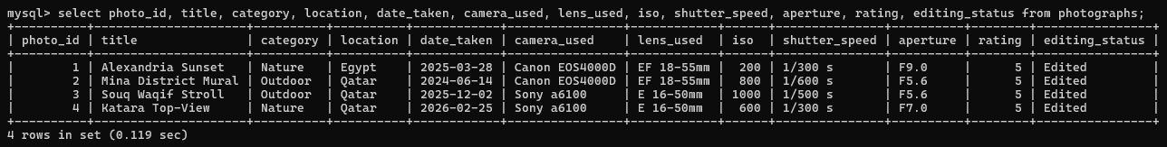

OUTPUTS

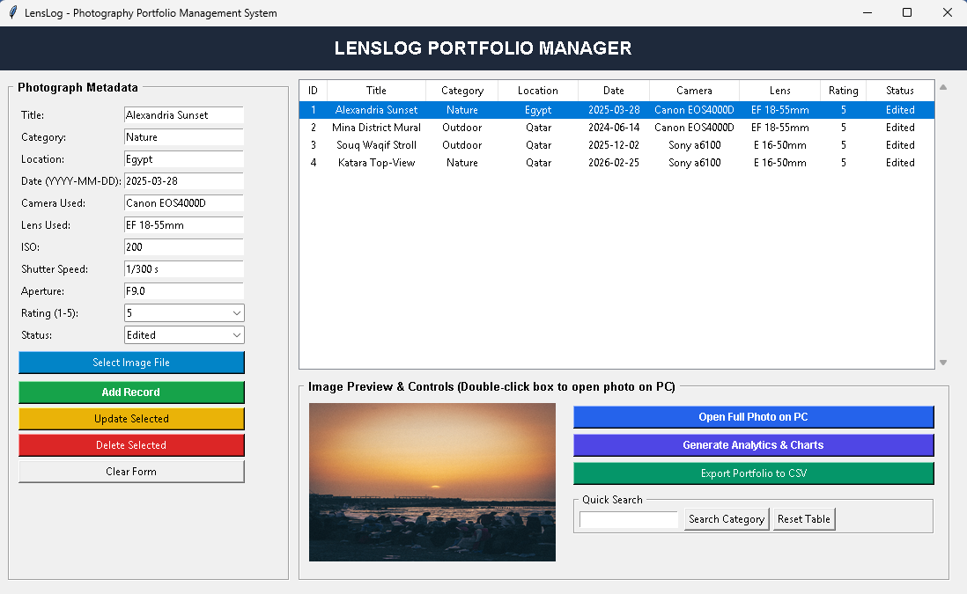
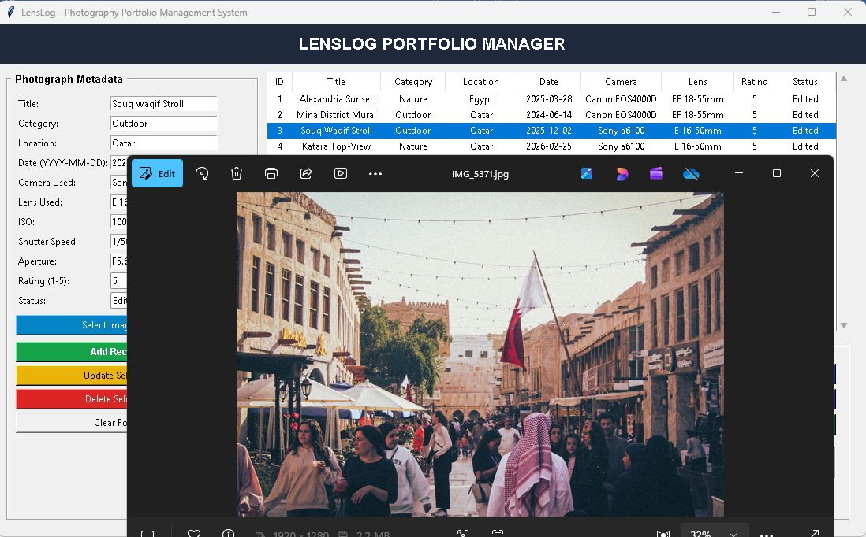
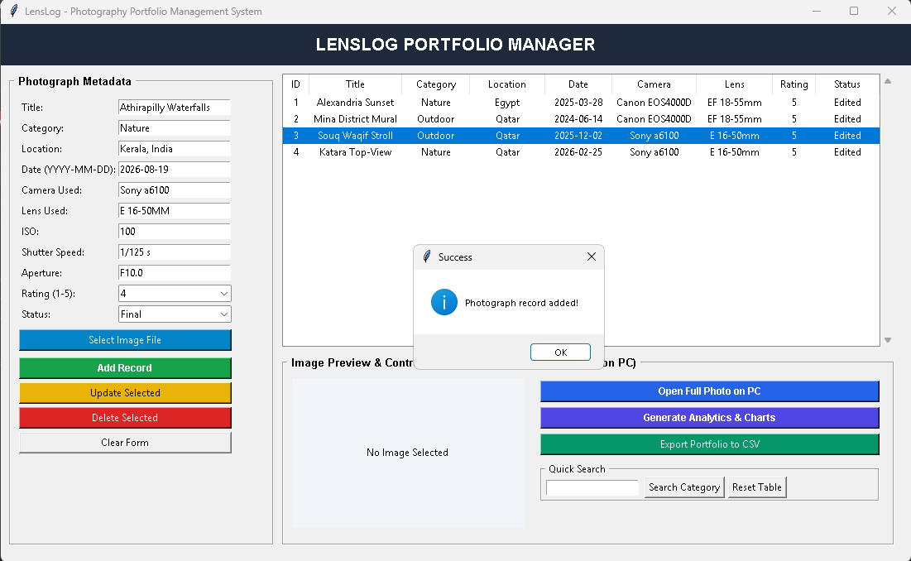
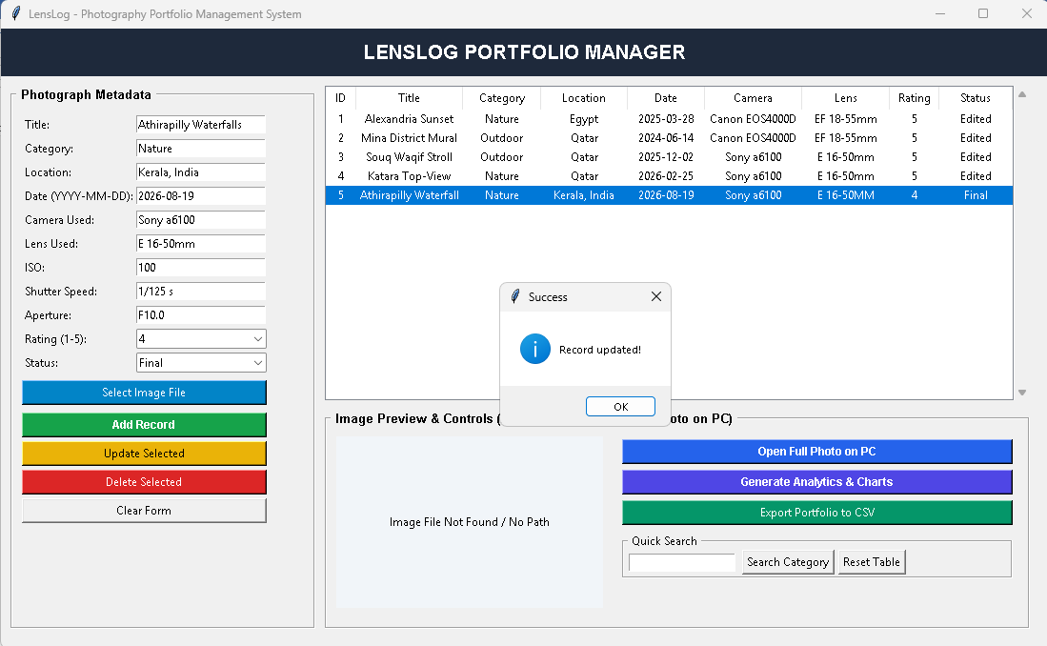
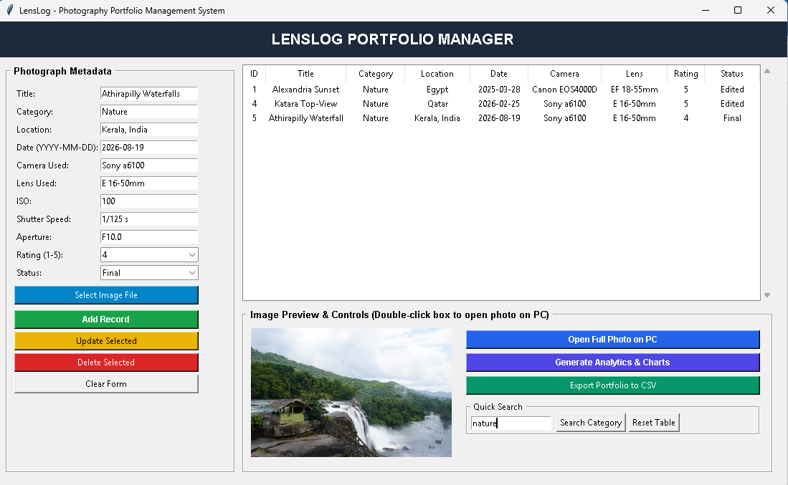

LIMITATIONS AND SCOPE

1. System Limitations While the LensLog Photography Portfolio Management System provides a complete solution for desktop portfolio tracking, it operates under specific technical boundaries:
- Single-User Local Architecture: Designed primarily as a standalone desktop application using a local MySQL server (localhost), limiting real-time concurrent updates across multiple workstations.
- Manual Metadata Input: Camera EXIF attributes (ISO, Aperture, Shutter Speed) are entered manually through form fields rather than automatically parsed from image file headers upon import.
- Local Storage Dependency: The system stores relative and absolute file path pointers rather than cloud URLs. Moving or renaming image directories on the host PC breaks file preview links until manually updated.
- Basic Search Capabilities: Search operations currently support primary visual fields (such as Category) rather than complex, multi-variable queries across EXIF parameters.

2. Scope of the System LensLog serves as a lightweight asset organization tool tailored specifically for independent photographers, digital archivists, and photography students. By decoupling high-resolution binary images from relational database tables, the system guarantees high data retrieval speeds while maintaining organized metadata catalogs. It provides essential CRUD workflow automation, dynamic OS-level image previewing, graphical statistics via Matplotlib, and seamless data exports to CSV formats.

BIBLIOGRAPHY

1. Textbooks & Academic Curricula
- Computer Science with Python (Class XII) – Sumita Arora, Dhanpat Rai & Co.
- Computer Science Textbook for Class XII (NCERT Code 083) – National Council of Educational Research and Training.
- Database Management Systems (3rd Edition) – Raghu Ramakrishnan & Johannes Gehrke, McGraw-Hill Education.
2. Technical Documentation & Online Specifications
- Python 3.x Standard Library Documentation – Python Software Foundation
URL: [https://docs.python.org/3/library/](https://docs.python.org/3/library/)
- MySQL 8.0 Reference Manual & Python Connector Guide – Oracle Corporation
URL: [https://dev.mysql.com/doc/refman/8.0/en/](https://dev.mysql.com/doc/refman/8.0/en/)
- Pillow (PIL Fork) Image Processing Library Documentation – Jeffrey A. Clark (Pillow Contributors)
URL: [https://pillow.readthedocs.io/](https://pillow.readthedocs.io/)
- Pandas Data Analysis & Matplotlib Visualization Libraries – Open Source Community
URL: [https://pandas.pydata.org/](https://pandas.pydata.org/) & [https://matplotlib.org/](https://matplotlib.org/)

